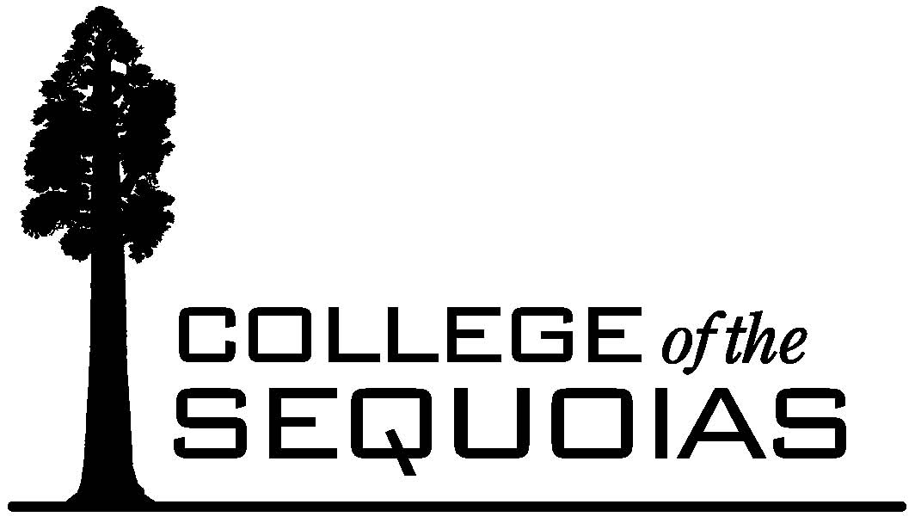 DECOS Committee
Distance Learning Addendum
Proposal

To promote careful planning and approval of distance learning classes, DECOS proposes that the following criteria comprise the COS Distance Learning Addendum (DLA):

- Justification
  - Why is it appropriate to offer this class as a distance education class?
  - How does the DE delivery of this class impact other departmental offerings?
  - How does the DE delivery of this class support the mission of the College?
- Regular, effective contact: Please describe how you will ensure and document regular, effective contact with and among your students.
  - Initiated interaction
    - Plan
    - Documentation
  - Frequency
    - Plan
    - Documentation
  - Managing unexpected instructor absence
    - Plan
    - Documentation
  - Types of Contact
    - Plan
    - Documentation
- Accessibility Statement: Can we fashion acceptable language from the following framework?
From the New Guidelines:
Access must be “anytime, anywhere” without the need for outside assistance unless as “last resort” (e.g., sign language interpreters, aides, etc.)
Provide “built-in” accommodations (e.g., captioning, descriptive narration)
Provide printed information in appropriate alternative formats
Access to DE courses, resources, and materials include audio, video, and text components of courses delivered via existing and emerging technologies
a.
b.
c.

